# **Working with JSON, Arrays, and Structs in BigQuery**

Create a new dataset to store the tables

In your BigQuery, click the three dots next to your project ID and select Create dataset:

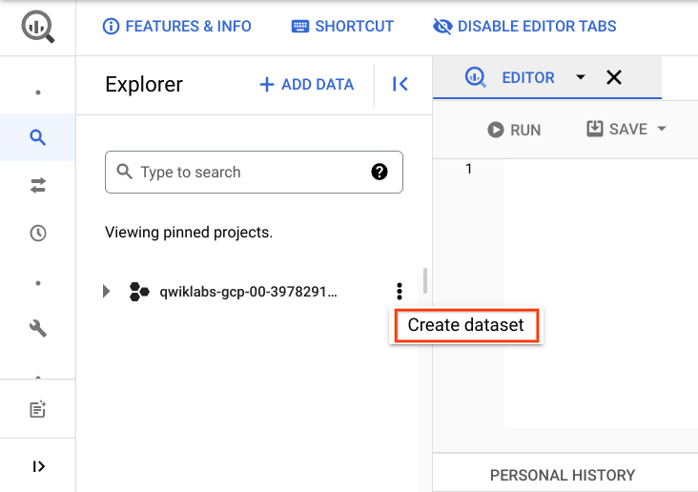

Name the new dataset fruit_store. Leave the other options at their default values (Data Location, Default Expiration). Click **Create dataset**.

**Practice working with Arrays in SQL**

Normally in SQL you will have a single value for each row like this list of fruits below:

|  |  |
| --- | --- |
| **Row** | **Fruit** |
| 1 | raspberry |
| 2 | blackberry |
| 3 | strawberry |
| 4 | cherry |

What if you wanted a list of fruit items for each person at the store? It could look something like this:

|  |  |  |
| --- | --- | --- |
| **Row** | **Fruit** | **Person** |
| 1 | raspberry | sally |
| 2 | blackberry | sally |
| 3 | strawberry | sally |
| 4 | cherry | sally |
| 5 | orange | frederick |
| 6 | apple | frederick |

In traditional relational database SQL, you would look at the repetition of names and immediately think to split the above table into two separate tables: Fruit Items and People. That process is called [normalization](https://en.wikipedia.org/wiki/Database_normalization) (going from one table to many). This is a common approach for transactional databases like mySQL.

Now, you're going to learn a different approach that stores data at different levels of granularity all in one table using repeated fields:

|  |  |  |
| --- | --- | --- |
| **Row** | **Fruit (array)** | **Person** |
| 1 | raspberry | sally |
| blackberry |  |
| strawberry |  |
| cherry |  |
| 2 | orange | frederick |
| apple |  |

What looks strange about the previous table?

* It's only two rows.
* There are multiple field values for Fruit in a single row.
* The people are associated with all of the field values.

What the key insight? The array data type!

An easier way to interpret the Fruit array:

|  |  |  |
| --- | --- | --- |
| **Row** | **Fruit (array)** | **Person** |
| 1 | [raspberry, blackberry, strawberry, cherry] | sally |
| 2 | [orange, apple] | frederick |

Both of these tables are exactly the same. There are two key learnings here:

* An array is simply a list of items in brackets [ ]
* BigQuery visually displays arrays as *flattened*. It simply lists the value in the array vertically (note that all of those values still belong to a single row)

Try it yourself. Enter the following in the BigQuery Query Editor:

#standardSQL

SELECT

['raspberry', 'blackberry', 'strawberry', 'cherry'] AS fruit_array

Click **Run**.

Now try executing this one:

#standardSQL

SELECT

['raspberry', 'blackberry', 'strawberry', 'cherry', 1234567] AS fruit_array

You should get an error that looks like the following:

**Error:** Array elements of types {INT64, STRING} do not have a common supertype at [3:1]

Here's the final table to query against:

#standardSQL

SELECT person, fruit_array, total_cost FROM `data-to-insights.advanced.fruit_store`;

Click **Run**.

After viewing the results, click the **JSON** tab to view the nested structure of the results.

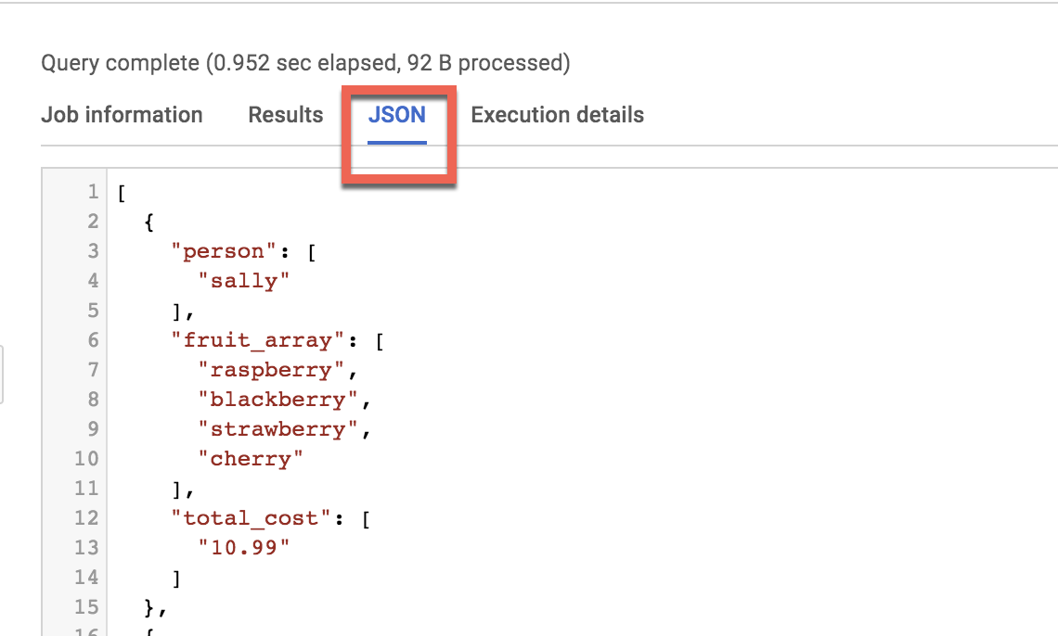

Loading semi-structured JSON into BigQuery

What if you had a JSON file that you needed to ingest into BigQuery?

Create a new table fruit_details in the dataset.

Click on fruit_store dataset, click on the vertical 3-dots, select **Open**. Now you will see the **Create Table** option. name the table fruit_details.

**Note**: You may have to widen your browser window to see the Create table option.

Add the following details for the table:

* **Source**: Choose **Google Cloud Storage** in the **Create table from** dropdown.
* **Select file from Cloud Storage bucket**: cloud-training/gsp416/shopping_cart.json
* **File format**: JSONL (Newline delimited JSON)

Call the new table fruit_details.

Check the checkbox of **Schema (Auto detect)**.

Click **Create table**.

In the schema, note that fruit_array is marked as REPEATED which means it's an array.

**Recap**

* BigQuery natively supports arrays
* Array values must share a data type
* Arrays are called REPEATED fields in BigQuery

**Creating your own arrays with ARRAY_AGG()**

Don't have arrays in your tables already? You can create them!

**Copy and Paste** the below query to explore this public dataset

SELECT

fullVisitorId,

date,

v2ProductName,

pageTitle

FROM `data-to-insights.ecommerce.all_sessions`

WHERE visitId = 1501570398

ORDER BY date

Click **Run** and view the results

Now, use the ARRAY_AGG() function to aggregate our string values into an array.

**Copy and Paste** the below query to explore this public dataset

SELECT

fullVisitorId,

date,

ARRAY_AGG(v2ProductName) AS products_viewed,

ARRAY_AGG(pageTitle) AS pages_viewed

FROM `data-to-insights.ecommerce.all_sessions`

WHERE visitId = 1501570398

GROUP BY fullVisitorId, date

ORDER BY date

Click **Run** and view the results

Next, use the ARRAY_LENGTH() function to count the number of pages and products that were viewed.

SELECT

fullVisitorId,

date,

ARRAY_AGG(v2ProductName) AS products_viewed,

ARRAY_LENGTH(ARRAY_AGG(v2ProductName)) AS num_products_viewed,

ARRAY_AGG(pageTitle) AS pages_viewed,

ARRAY_LENGTH(ARRAY_AGG(pageTitle)) AS num_pages_viewed

FROM `data-to-insights.ecommerce.all_sessions`

WHERE visitId = 1501570398

GROUP BY fullVisitorId, date

ORDER BY date

Next, deduplicate the pages and products so you can see how many unique products were viewed by adding DISTINCT to ARRAY_AGG()

SELECT

fullVisitorId,

date,

ARRAY_AGG(DISTINCT v2ProductName) AS products_viewed,

ARRAY_LENGTH(ARRAY_AGG(DISTINCT v2ProductName)) AS distinct_products_viewed,

ARRAY_AGG(DISTINCT pageTitle) AS pages_viewed,

ARRAY_LENGTH(ARRAY_AGG(DISTINCT pageTitle)) AS distinct_pages_viewed

FROM `data-to-insights.ecommerce.all_sessions`

WHERE visitId = 1501570398

GROUP BY fullVisitorId, date

ORDER BY date

**Recap**

You can do some pretty useful things with arrays like:

* finding the number of elements with ARRAY_LENGTH(<array>)
* deduplicating elements with ARRAY_AGG(DISTINCT <field>)
* ordering elements with ARRAY_AGG(<field> ORDER BY <field>)
* limiting ARRAY_AGG(<field> LIMIT 5)

**Querying datasets that already have ARRAYs**

The BigQuery Public Dataset for Google Analytics bigquery-public-data.google_analytics_sample has many more fields and rows than our course dataset data-to-insights.ecommerce.all_sessions. More importantly, it already stores field values like products, pages, and transactions natively as ARRAYs.

**Copy and Paste** the below query to explore the available data and see if you can find fields with repeated values (arrays)

SELECT

*

FROM `bigquery-public-data.google_analytics_sample.ga_sessions_20170801`

WHERE visitId = 1501570398

**Run** the query.

**Scroll right** in the results until you see the hits.product.v2ProductName field (multiple field aliases are discussed shortly).

The amount of fields available in the Google Analytics schema can be overwhelming for analysis. Try to query just the visit and page name fields like before.

SELECT

visitId,

hits.page.pageTitle

FROM `bigquery-public-data.google_analytics_sample.ga_sessions_20170801`

WHERE visitId = 1501570398

You will get an error: Cannot access field page on a value with type ARRAY<STRUCT<hitNumber INT64, time INT64, hour INT64, ...>> at [3:8]

Before you can query REPEATED fields (arrays) normally, you must first break the arrays back into rows.

For example, the array for hits.page.pageTitle is stored currently as a single row like:

['homepage','product page','checkout']

and it needs to be

['homepage',

'product page',

'checkout']

How do you do that with SQL?

Answer: Use the UNNEST() function on your array field:

SELECT DISTINCT

visitId,

h.page.pageTitle

FROM `bigquery-public-data.google_analytics_sample.ga_sessions_20170801`,

UNNEST(hits) AS h

WHERE visitId = 1501570398

LIMIT 10

We'll cover UNNEST() more in detail later but for now just know that:

* You need to UNNEST() arrays to bring the array elements back into rows
* UNNEST() always follows the table name in your FROM clause (think of it conceptually like a pre-joined table)

**Introduction to STRUCTs**

You may have wondered why the field alias hit.page.pageTitle looks like three fields in one separated by periods. Just as ARRAY values give you the flexibility to *go deep* into the granularity of your fields, another data type allows you to *go wide* in your schema by grouping related fields together. That SQL data type is the [STRUCT](https://cloud.google.com/bigquery/docs/reference/standard-sql/data-types#struct-type) data type.

The easiest way to think about a STRUCT is to consider it conceptually like a separate table that is already pre-joined into your main table.

A STRUCT can have:

* one or many fields in it
* the same or different data types for each field
* it's own alias

Sounds just like a table right?

Explore a dataset with STRUCTs

To open the **bigquery-public-data** dataset, click **+Add Data** > **Pin a project** > **Enter Project Name**, then write the bigquery-public-data name. Click **Pin**.

The bigquery-public-data project is listed in the Explorer section.

Open **bigquery-public-data**.

Find and open **google_analytics_sample** dataset.

Click the **ga_sessions** table.

As you can imagine, there is an incredible amount of website session data stored for a modern ecommerce website.

The main advantage of having 32 STRUCTs in a single table is it allows you to run queries like this one without having to do any JOINs:

SELECT

visitId,

totals.*,

device.*

FROM `bigquery-public-data.google_analytics_sample.ga_sessions_20170801`

WHERE visitId = 1501570398

LIMIT 10

Note: The .* syntax tells BigQuery to return all fields for that STRUCT (much like it would if totals.* was a separate table we joined against)

Storing your large reporting tables as STRUCTs (pre-joined "tables") and ARRAYs (deep granularity) allows you to:

* gain significant performance advantages by avoiding 32 table JOINs
* get granular data from ARRAYs when you need it but not be punished if you don't (BigQuery stores each column individually on disk)
* have all the business context in one table as opposed to worrying about JOIN keys and which tables have the data you need

**Practice with STRUCTs and ARRAYs**

The next dataset will be lap times of runners around the track. Each lap will be called a "split".



With this query, try out the STRUCT syntax and note the different field types within the struct container:

#standardSQL

SELECT STRUCT("Rudisha" as name, 23.4 as split) as runner

|  |  |  |
| --- | --- | --- |
| **Row** | **runner.name** | **runner.split** |
| 1 | Rudisha | 23.4 |

What do you notice about the field aliases? Since there are fields nested within the struct (name and split are a subset of runner) you end up with a dot notation.

With an array of course! Run the below query to confirm:

#standardSQL

SELECT STRUCT("Rudisha" as name, [23.4, 26.3, 26.4, 26.1] as splits) AS runner

|  |  |  |
| --- | --- | --- |
| **Row** | **runner.name** | **runner.splits** |
| 1 | Rudisha | 23.4 |
| 26.3 |
| 26.4 |
| 26.1 |

To recap:

* Structs are containers that can have multiple field names and data types nested inside.
* Arrays can be one of the field types inside of a Struct (as shown above with the splits field).

Practice ingesting JSON data

Create a new dataset titled racing.

Create a new table titled **race_results**. Click on racing dataset and click Create table.

**Note**: You may have to widen your browser window to see the Create table option.

* **Source**: select **Google Cloud Storage** under **Create table from** dropdown.
* **Select file from Cloud Storage bucket**: data-insights-course/labs/optimizing-for-performance/race_results.json
* **File format**: JSONL (Newline delimited JSON)
* In **Schema**, click on **Edit as text** slider and add the following:

[

{

"name": "race",

"type": "STRING",

"mode": "NULLABLE"

},

{

"name": "participants",

"type": "RECORD",

"mode": "REPEATED",

"fields": [

{

"name": "name",

"type": "STRING",

"mode": "NULLABLE"

},

{

"name": "splits",

"type": "FLOAT",

"mode": "REPEATED"

}

]

}

]

Click **Create table**.

After the load job is successful, preview the schema for the newly created table:

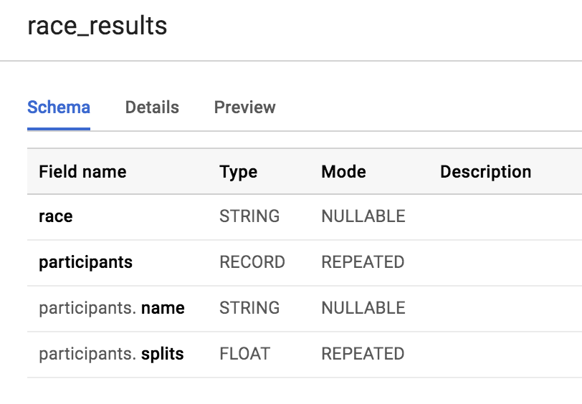

Which field is the STRUCT? How do you know?

The **participants** field is the STRUCT because it is of type RECORD

Which field is the ARRAY?

The participants.splits field is an array of floats inside of the parent participants struct. It has a REPEATED Mode which indicates an array. Values of that array are called nested values since they are multiple values inside of a single field.

Practice querying nested and repeated fields

Let's see all of our racers for the 800 Meter race.

#standardSQL

SELECT * FROM racing.race_results

How many rows were returned?

Answer: 1

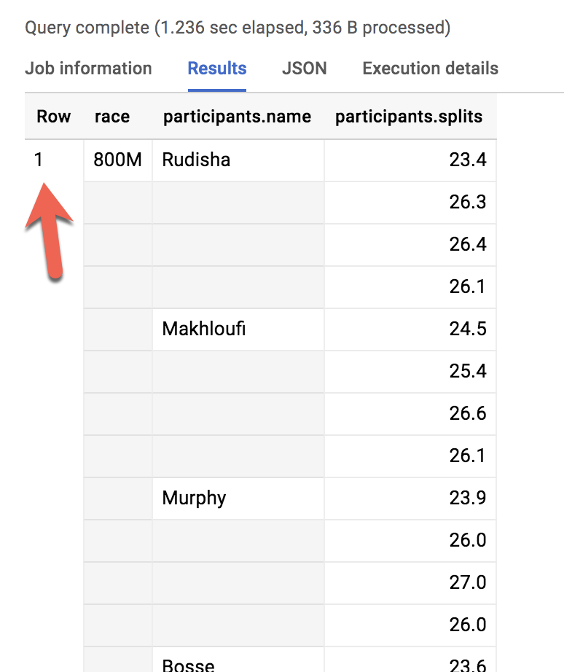

What if you wanted to list the name of each runner and the type of race?

Run the below schema and see what happens:

#standardSQL

SELECT race, participants.name

FROM racing.race_results

Error: Cannot access field name on a value with type ARRAY<STRUCT<name STRING, splits ARRAY<FLOAT64>>>> at [2:27]

Much like forgetting to GROUP BY when you use aggregation functions, here there are two different levels of granularity. One row for the race and three rows for the participants names. So how do you change this...

|  |  |  |
| --- | --- | --- |
| **Row** | **race** | **participants.name** |
| 1 | 800M | Rudisha |
| 2 | ??? | Makhloufi |
| 3 | ??? | Murphy |

...to this:

|  |  |  |
| --- | --- | --- |
| **Row** | **race** | **participants.name** |
| 1 | 800M | Rudisha |
| 2 | 800M | Makhloufi |
| 3 | 800M | Murphy |

In traditional relational SQL, if you had a races table and a participants table what would you do to get information from both tables? You would JOIN them together. Here the participant STRUCT (which is conceptually very similar to a table) is already part of your races table but is not yet correlated correctly with your non-STRUCT field "race".

Can you think of what two word SQL command you would use to correlate the 800M race with each of the racers in the first table?

Answer: CROSS JOIN

Great! Now try running this:

#standardSQL

SELECT race, participants.name

FROM racing.race_results

CROSS JOIN

participants # this is the STRUCT (it is like a table within a table)

Table name "participants" missing dataset while no default dataset is set in the request.

Even though the participants STRUCT is like a table, it is still technically a field in the racing.race_results table.

Add the dataset name to the query:

#standardSQL

SELECT race, participants.name

FROM racing.race_results

CROSS JOIN

race_results.participants # full STRUCT name

And click **Run**.

Wow! You've successfully listed all of the racers for each race!

|  |  |  |
| --- | --- | --- |
| **Row** | **race** | **name** |
| 1 | 800M | Rudisha |
| 2 | 800M | Makhloufi |
| 3 | 800M | Murphy |
| 4 | 800M | Bosse |
| 5 | 800M | Rotich |
| 6 | 800M | Lewandowski |
| 7 | 800M | Kipketer |
| 8 | 800M | Berian |

You can simplify the last query by:

* Adding an alias for the original table
* Replacing the words "CROSS JOIN" with a comma (a comma implicitly cross joins)

This will give you the same query result:

#standardSQL

SELECT race, participants.name

FROM racing.race_results AS r, r.participants

If you have more than one race type (800M, 100M, 200M), wouldn't a CROSS JOIN just associate every racer name with every possible race like a cartesian product?

**Answer**: No. This is a *correlated* cross join which only unpacks the elements associated with a single row. For a greater discussion, see [working with ARRAYs and STRUCTs](https://cloud.google.com/bigquery/docs/reference/standard-sql/arrays#flattening-arrays)

Recap of STRUCTs:

* A SQL [STRUCT](https://cloud.google.com/bigquery/docs/reference/standard-sql/data-types#struct-type) is simply a container of other data fields which can be of different data types. The word struct means data structure. Recall the example from earlier:
* STRUCT(``"Rudisha" as name, [23.4, 26.3, 26.4, 26.1] as splits``)`` AS runner
* STRUCTs are given an alias (like runner above) and can conceptually be thought of as a table inside of your main table.
* STRUCTs (and ARRAYs) must be unpacked before you can operate over their elements. Wrap an UNNEST() around the name of the struct itself or the struct field that is an array in order to unpack and flatten it.

**Lab Question: STRUCT()**

Answer the below questions using the racing.race_results table you created previously.

**Task:** Write a query to COUNT how many racers were there in total.

To start, use the below partially written query:

#standardSQL

SELECT COUNT(participants.name) AS racer_count

FROM racing.race_results

**Hint:** Remember you will need to cross join in your struct name as an additional data source after the FROM.

Possible Solution:

#standardSQL

SELECT COUNT(p.name) AS racer_count

FROM racing.race_results AS r, UNNEST(r.participants) AS p

|  |  |
| --- | --- |
| **Row** | **racer_count** |
| 1 | 8 |

Answer: There were 8 racers who ran the race.

**Lab Question: Unpacking ARRAYs with UNNEST( )**

Write a query that will list the total race time for racers whose names begin with R. Order the results with the fastest total time first. Use the UNNEST() operator and start with the partially written query below.

Complete the query:

#standardSQL

SELECT

p.name,

SUM(split_times) as total_race_time

FROM racing.race_results AS r

, r.participants AS p

, p.splits AS split_times

WHERE

GROUP BY

ORDER BY

;

Hint:

* You will need to unpack both the struct and the array within the struct as data sources after your FROM clause
* Be sure to use aliases where appropriate

Possible Solution:

#standardSQL

SELECT

p.name,

SUM(split_times) as total_race_time

FROM racing.race_results AS r

, UNNEST(r.participants) AS p

, UNNEST(p.splits) AS split_times

WHERE p.name LIKE 'R%'

GROUP BY p.name

ORDER BY total_race_time ASC;

|  |  |  |
| --- | --- | --- |
| **Row** | **name** | **total_race_time** |
| 1 | Rudisha | 102.19999999999999 |
| 2 | Rotich | 103.6 |

**Filtering within ARRAY values**

You happened to see that the fastest lap time recorded for the 800 M race was 23.2 seconds, but you did not see which runner ran that particular lap. Create a query that returns that result.

Complete the partially written query:

#standardSQL

SELECT

p.name,

split_time

FROM racing.race_results AS r

, r.participants AS p

, p.splits AS split_time

WHERE split_time = ;

Possible Solution:

#standardSQL

SELECT

p.name,

split_time

FROM racing.race_results AS r

, UNNEST(r.participants) AS p

, UNNEST(p.splits) AS split_time

WHERE split_time = 23.2;

|  |  |  |
| --- | --- | --- |
| **Row** | **name** | **split_time** |
| 1 | Kipketer | 23.2 |